60x60

Vox Novus In collaboration with ICMC (International Computer Music Conference 2010) is inviting composers to submit recorded works 60 seconds or less in length to be included in its seventh annual 60x60 project. 60 compositions will be selected to be played continuously in a one-hour concert.

The 60x60 concert season will have multiple performances in several different mixes and multi-media throughout the world. Mixes planned for 60x60 2010 include the International Mix, 360 degrees of 60x60 at ICMC, the UnTwelve Mix (including only microtonal works) as well as any other past mix (i.e. Midwest Mix, UK Mix, etc) where more than 60 submissions are received.

Please submit a ZIP file containing the submission form and an AIFF or WAV (16bits 44.1kHz) recording of the work at the ICMC website:
http://music.oc.cct.lsu.edu/author/submit.php

During the concert each of the 60 pieces selected will begin precisely at the beginning of the minute, this will mark the end of one piece and the beginning of another. There will be no pause between the pieces. Works may be less than 60 seconds in length, but may not exceed 60 seconds. Works selected that are less than 60 seconds long will be “padded” with silence either before, after, or surrounding the composition. Please note that the total duration of the work including silence may NOT exceed sixty seconds.

The 60x60 project’s definition of a record work is as follows: any work created as a musical composition which is captured on recorded media, which does not require live performers for its production in broadcast at concert halls, radio, multi-media, etc. Its creation can include but not limited to acoustic instruments, voice, environmental sources, and computer (Sampling, MIDI, C Sound, ProTools, etc.)

Acoustic compositions should be submitted with the understanding that it is their recording that is of prime importance and is what will be used to determine its selection. Scores of works are strongly discouraged and will not be used in the selection process.

60x60 is a project of “signature works” and short works created specifically for the 60x60 project. Excerpts of larger works are strongly discouraged. Works generated from procedures (i.e. mathematical matrices, organizational systems, or computer programs,) remixed works, or themes and motives recomposed from other of the composer's own work are acceptable.

The call is open to composers of any nationality, age, or career stage. Works submitted must not have been previously performed or broadcasted. The submission form must be sent at the same time with the submitted work. Submission form must contain the composer’s name, address, email, phone number, composition title, and composition length (60 seconds or less.) Biographies and program notes may be no longer than 100 words in length.

Submissions must be uploaded by January 7th, 2010. Selected works will be announced on February 15th, 2010.

Submissions must include:
Submission Forms as a PDF or MSWord can be downloaded at:
http://www.VoxNovus.com/60x60/Call.htm

The ZIP file including the submission form and the AIFF/WAV sound file must be uploaded at ICMC website:
http://music.oc.cct.lsu.edu/author/submit.php
or
http://music.oc.cct.lsu.edu/openconf.php

Works selected for the 2010 60x60 project will be announced on February 15th, 2010.
Composers will be notified of the results by email or they can visit http://www.VoxNovus.com

Any questions regarding the call for works can be addressed to Support@VoxNovus.com

60x60

Submission Form

First Name Last Name

Address

Address

City State (or Province) Postal Code Country

E-Mail Address URL (World Wide Web Address) Phone Number

Composition Title Length Track

Biography (100 words or less)

Program notes (Composition Description 100 words or less)

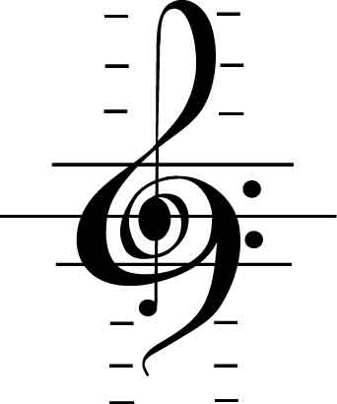



60x60 c/o Robert Voisey Radio City Station P.O. Box 1607 NY, NY 10101

